PAGE 17 AFTER PRESSURE

Installation Guidelines- Flanged Flow Meter-VIR 850 Series

1. Delivery and Acceptance
When receiving deliveries that include more than one meter, it is essential to verify that each sensor is correctly matched with its corresponding converter. This can be confirmed by checking the system rating plates.

2. Meter Handling
- Always lift the meter by its flanges or transport eyelets — never by the connecting box or sensors.
- Recommended lifting method: Use textile slings only. Avoid chains or steel cables, as they can cause physical damage.
- Do not place any auxiliary components inside the sensor during transport, as this may cause irreversible damage.
- Whenever possible, transport the flowmeter to the installation site in its original packaging to ensure protection.

3. Storage Before Installation
Before installation, observe the following storage requirements:
- Maintain the recommended ambient temperature and relative humidity.
- Keep the meter away from direct sunlight to prevent display damage.
- Store the meter in its original packaging. Remove any protective covering or casing only just before installation.

4. Installation Conditions

General Assembly Rules
During the mechanical installation of the meter, follow these essential guidelines:
- Remove the protective wrapping and casing immediately before installation.
- Ensure the arrow on the sensor body points in the direction of fluid flow.
- When installing the meter in a vertical pipeline, fluid must flow upwards.
- The pipe flanges should be aligned and strictly parallel.
- The internal diameters of the pipeline and sealing components must match the diameter of the meter sensor.

Specifications:

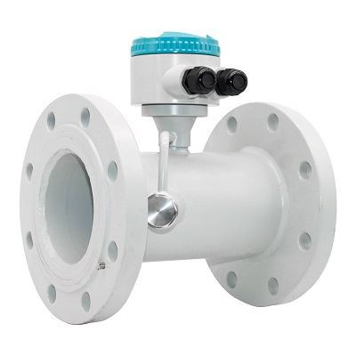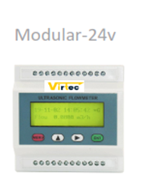
Dimension & Flow details:

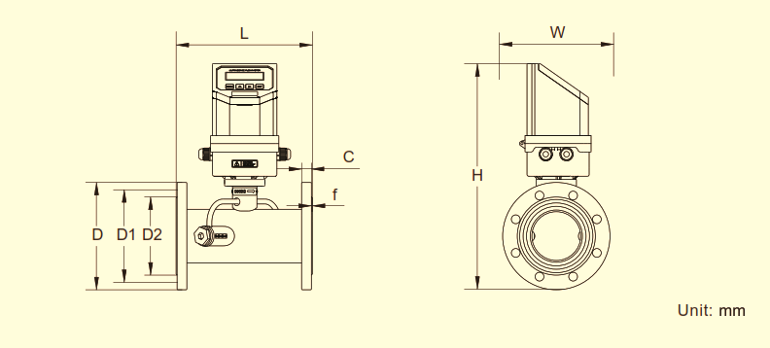

Installation Requirements-VIR850

Sealing and Mechanical Support
- Ensure that the sealing gasket is correctly positioned between the flanges and does not intrude into the flow path.
- The piping must be adequately supported on both the inlet and outlet sides of the meter to minimize mechanical stresses such as vibration, bending, or tension on the sensor.
- Do not place any piping support or brace directly beneath the meter sensor.
- The converter must be shielded from direct sunlight to avoid damage or operational issues.
Select an installation location that provides easy access for operators to the converter and meter rating plates.
- The sensor must always remain completely flooded with fluid, with minimal risk of air entrapment or aeration.
⚠️ Important Note: After the meter is installed, no arc welding should be performed on adjacent piping. Additionally, do not weld flanges onto piping ends when the meter sensor is already attached.

Straight Pipe Requirements (per EN ISO 4064-5)
To ensure accurate measurement, the installation location must suitable fluid flow
- Consistent velocity profile
- Full flooding of the sensor
- Prevention of cavitation or foaming

Straight Piping Sections
- The inlet and outlet of the meter must include straight piping sections, with lengths defined as multiples of the pipe’s internal diameter (DN).
- For bi-directional flow, ensure the same straight lengths on both sides of the meter.
- The pipe inner diameter must closely match the sensor’s — it should not be smaller, and should not exceed it by more than 1%.
- Avoid sharp edges or steps at the pipe-sensor joints that could create turbulence.
- Ideally, install the sensor upstream of any flow-disturbing components like pumps or valves.
- If the system uses pumps that generate pressure pulses (e.g., pneumatic pumps), a hydraulic damper should be installed to smooth out flow disturbances.

Straight Pipe Length Guidelines by Sensor Type-UF Series (Single-Ray Sensor)
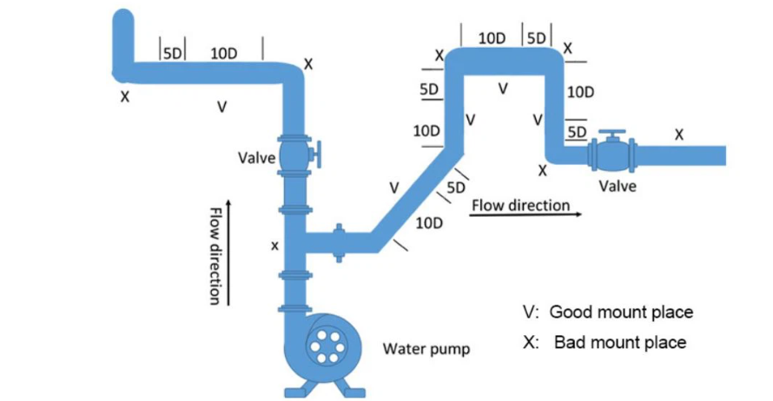

Minimum straight lengths:
- 5 DN at the inlet
- 10DN at the outlet
For bi-directional flow, both inlet and outlet require 5 DN.If multiple flow-disturbing elements are near the meter (e.g., bends, reducers), increase straight lengths proportionally.
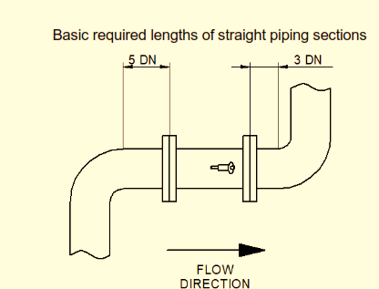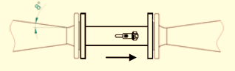
If the flowmeter is smaller than the connected piping, use conical reducers with an apex angle not exceeding 15°. For horizontal piping systems, eccentric reducers should be used to avoid air bubble formation (refer to standard ČSN ISO 6817). Tapered reducers with a slope angle up to 8° can be treated as part of the straight piping section.

Limiting Pump Operation Effects
To prevent pressure drops inside the sensor and avoid issues such as cavitation, gas bubble formation, or fluid foaming:
- Always position the pump on the inlet side of the flowmeter.
- This configuration helps maintain higher pressure in the system, keeping the fluid below its saturated vapor pressure and thereby suppressing cavitation.
- A minimum of 20 DN of straight piping is required between the pump and the flowmeter sensor.
  - 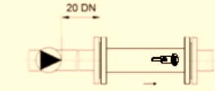

Limiting Effects of Closing and Regulation Valves
To maintain a stable velocity profile and minimize cavitation risk:
- Install closing or regulating valves preferably on the outlet side of the flowmeter.
- Ensure a minimum of 10 DN of straight piping between the flowmeter and the nearest valve.

The meter sensor shall not be located at the top of the piping system or, in vertical position, with the fluid flow direction downwards, especially if the piping discharge point is near. Observance of this rule will prevent measurement errors due to higher concentration of air bubbles inside the sensor.

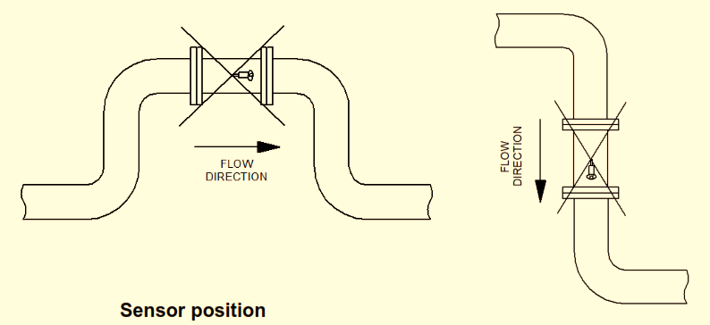The flowmeter position in the piping can be both horizontal and vertical.

Suitable deviation from the ideal position of horizontal axis:

VIR (single-ray) ± 30° in both directions.

If a flowmeter is to be installed in a thermally insulated piping, thermal insulation is usually applied on the meter sensor too. In such a case, observe the following rules:

• Thermal insulation is placed on the sensor only. • The meter converter shall be protected against undesirable heating (by direct sunshine or water or rain)

Installation Process: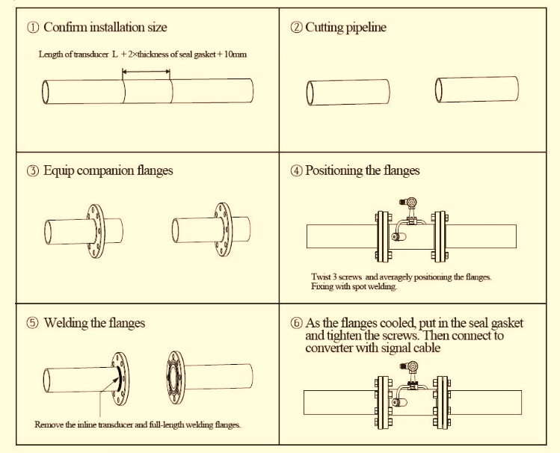

PAGE 19 OF AFTER ABOVE DETAILS

VIR-850 Flow Meter With Integrated Transmitter/Heat Calculator

